Optimizing Resume Formats Using Reinforcement Learning

CSC2558 - Project Report

1. Abstract

2. Personal Takeaways

3. Introduction

3.1 Motivation

3.2 Contribution

4. Related Work

5. Data Preparation

5.1 Using Factorial Design for Resume Creation

5.2 Dataset Creation

6. Data Visualization

7. Adaptive ε Greedy Algorithm

8. Result

9. Conclusion

10. Future Work

11. Resources

12. References

Optimizing Resume Formats using Reinforcement Learning

### CSC2558 - Project Report

Abdur Rahman ([abdur@cs.toronto.edu](mailto:abdur@cs.toronto.edu)), Sarthak Narayan ([sarthak@cs.toronto.edu](mailto:sarthak@cs.toronto.edu)), Devashish Khairnar ([devashish@cs.toronto.edu](mailto:devashish@cs.toronto.edu)), Sanjukta De ([sanjuktade@cs.toronto.edu](mailto:sanjuktade@cs.toronto.edu))

# 

# Abstract

This project aims to experiment with different resume formats to find the best one based on user feedback. Four resume formats are created using design thinking strategies and factorial design to analyze the effects an independent variable has on a dependent variable on the level of other independent variables. A group of users is presented with one of the four resumes at random and they are asked to rate the resumes on various criteria. Furthermore, an ε-greedy strategy has been adapted to simulate the likelihood of selecting the best resume format over the other formats. Google forms were used to conduct the study and collect feedback. Also, the questions in the form were based on different resume design patterns.

# Personal Takeaways

**Devashish Pradeep Khairnar:**

I had the chance to collaborate with my colleague Sanjukta on the project's data collection and ε-greedy experimentation sections. We interacted with the MScAC class of 2024 while gathering data, which allowed me to make new personal and professional contacts. This, in my opinion, will be extremely beneficial to my career as a computer scientist. Additionally, in line with the project's goals, I learned what qualities make a strong Resume and what to do and not to do when putting up a resume for the upcoming ARIE'23 internship expo. Along with these I also learned about the ε-greedy methodology of random experimentation and how it helps us to choose an optimum solution in case of a multi-arm problem.

**Sanjukta De**

Working on this project gave me the chance to learn a new approach and use it on a real project, as well as to get insight into the elements that would help me create a good resume for the future interview process. This project taught me how to think creatively and in a way that aligns with my academic interests, which was one of the most significant things I took away from it. Utilizing several strategies and examining the issue from many angles was fascinating. This project would be useful in an interview since it finds a straightforward yet effective solution to a problem that every student encounters in the real world. Since we broadened the initiative beyond the varied MScAC cohort to include alumni as well, we received a variety of viewpoints and suggestions that were really helpful in helping us identify the best approach.

# Introduction

## **3.1 Motivation**

A resume is an important tool for job search as it offers a brief summary of a candidate’s relevant skills and qualities. Resumes help employers make hiring decisions and help us get interviews. According to a famous study, hiring managers only take an average of six seconds to decide whether to keep or trash a resume. So it is incredibly important that a candidate’s resume be appealing at the very first glance.

One of the most important considerations when designing a resume is how to structure the content and ensure that the resume is presentable. A resume is one of the first pieces of document that a hiring manager or a recruiter looks at before deciding whether or not to go forward with the interviews with that person. Furthermore, there are computerized systems that scan the resume to extract skills and shortlist candidates.

It is difficult to decide what resume format works the best, as several formats can be found online. This project tries to find the best resume format among the most popular resume formats. As all four of us are MScAC students, we are working on drafting our resumes for the incoming interviews for the applied research internship. This experiment will help us directly in our resume-building process. We’ve designed this experiment so that it can be extended to any number of resume formats.

## **3.2 Contribution**

In the experiment, four resumes have been created using Factorial Design. We conduct an experiment by randomly showing one of these four resumes to a participant and asking them to rate the resume between 1 to 5 on different criteria. We then simulate the experiment using the ε-greedy algorithm on the data collected in the previous step. The Adaptive ε-Greedy algorithm in Reinforcement Learning is based on the classic ε-greedy method. The agent's state is modified based on some stimulus to maximize the reward. This dynamic system helps attain a balance between exploration and exploitation. The aim is to find the most optimal resume format that can be used by the MScAC cohort in the upcoming internship interviews.

# Related Work

In our study, we propose using factorial design to create resume designs which will then be used to find the most optimal resume design using the ε-greedy algorithm. An organized approach to figuring out how elements influencing a process related to the process's output is to use factorial design. Using factorial design to design, test, and optimize web pages has previously been experimented with by [4] which finds the optimal criteria for factors resolution design and aberration design. Using a similar approach we use two factors and two levels to determine different resume formats and test to find the best format.

[8] suggests different methodologies of planning and analyzing online A/B experiments which have been employed in our project. Since an online medium (Google forms) has been used in our project, the project is much more scalable and can even be extended outside the MScAC cohort and more design factors can be considered to create different resume formats for a much wider user group.

The Adaptive ε-Greedy algorithm was first suggested in [5] to balance exploration and exploitation in reinforcement learning. Unlike the ε-greedy method which has a static probability ε value. Using adaptive technology, the value of ε can be varied in a controlled way and this value is calculated using the rewards received from the environment. This dynamic ε can adapt to the behaviour of the domain.

# Data Preparation

A particular resume version was assigned randomly to a group of students. The responses that were obtained from the experiment were collected and the adaptive ε-greedy algorithm was applied to the same. The resumes are hereafter referred to as Version 1, Version 2, Version 3, and Version 4.

The experiment was conducted on 120 MScAC students/alumni out of which 98 users sent a response and 22 did not. We tabulate the responses and analyze the user distribution based on a few criteria. Then we apply the adaptive ε greedy algorithm to get the optimal resume design.

## **5.1 Using Factorial Design for Resume Creation**

Four resumes were shared that were reviewed by users based on different design criteria. All the resumes are single-paged and have different content layouts and colour schemes. The different resumes formats are

* Version 1 (top left) - two-column, grayscale
* Version 2 (top right) - no column, grayscale
* Version 3 (bottom left) - no column, coloured
* Version 4 (bottom right) - two-column, coloured

Factorial Design refers to an experimental design that consists of two or more factors, each of which has a variety of discrete potential values or levels. This allows for the investigation of all potential factor-level combinations. The following is measured with a factorial design:

* Main Effect: The change brought about by a change in a factor's level is referred to as the main effect.
* Interaction Effect: When one independent variable's impact on the dependent variable is influenced by another independent variable.

The between-subject factorial design has been selected for this project, meaning that each subject only experiences one of the experimental conditions and is assigned to a separate condition.

The resumes were created using a 2x2 factorial design. Factorial design is used to understand the effects of two independent variables (colours and columns in this case) on a single dependent variable (the resume design).

* Independent Variable 1: Colours
  + Levels: Black and White, Coloured
* Independent Variable 2: Number of Columns
  + Levels: 1 Column, 2 Columns

**Table 1: 2x2 factorial design to study the effect of colour and columns on resume design**

|  |  | Colours | |
| --- | --- | --- | --- |
|  |  | Black and White | Coloured |
| Number of Columns | 2 Columns | Version 1 | Version 4 |
| No Columns | Version 2 | Version 3 |

Below are the four resume designs we used in this experiment. The contents of these resumes are the same. Each resume has an objective, experiences, projects, education and skills.

The experiment is conducted this way to ensure that the resume contents do not influence the resume choices.

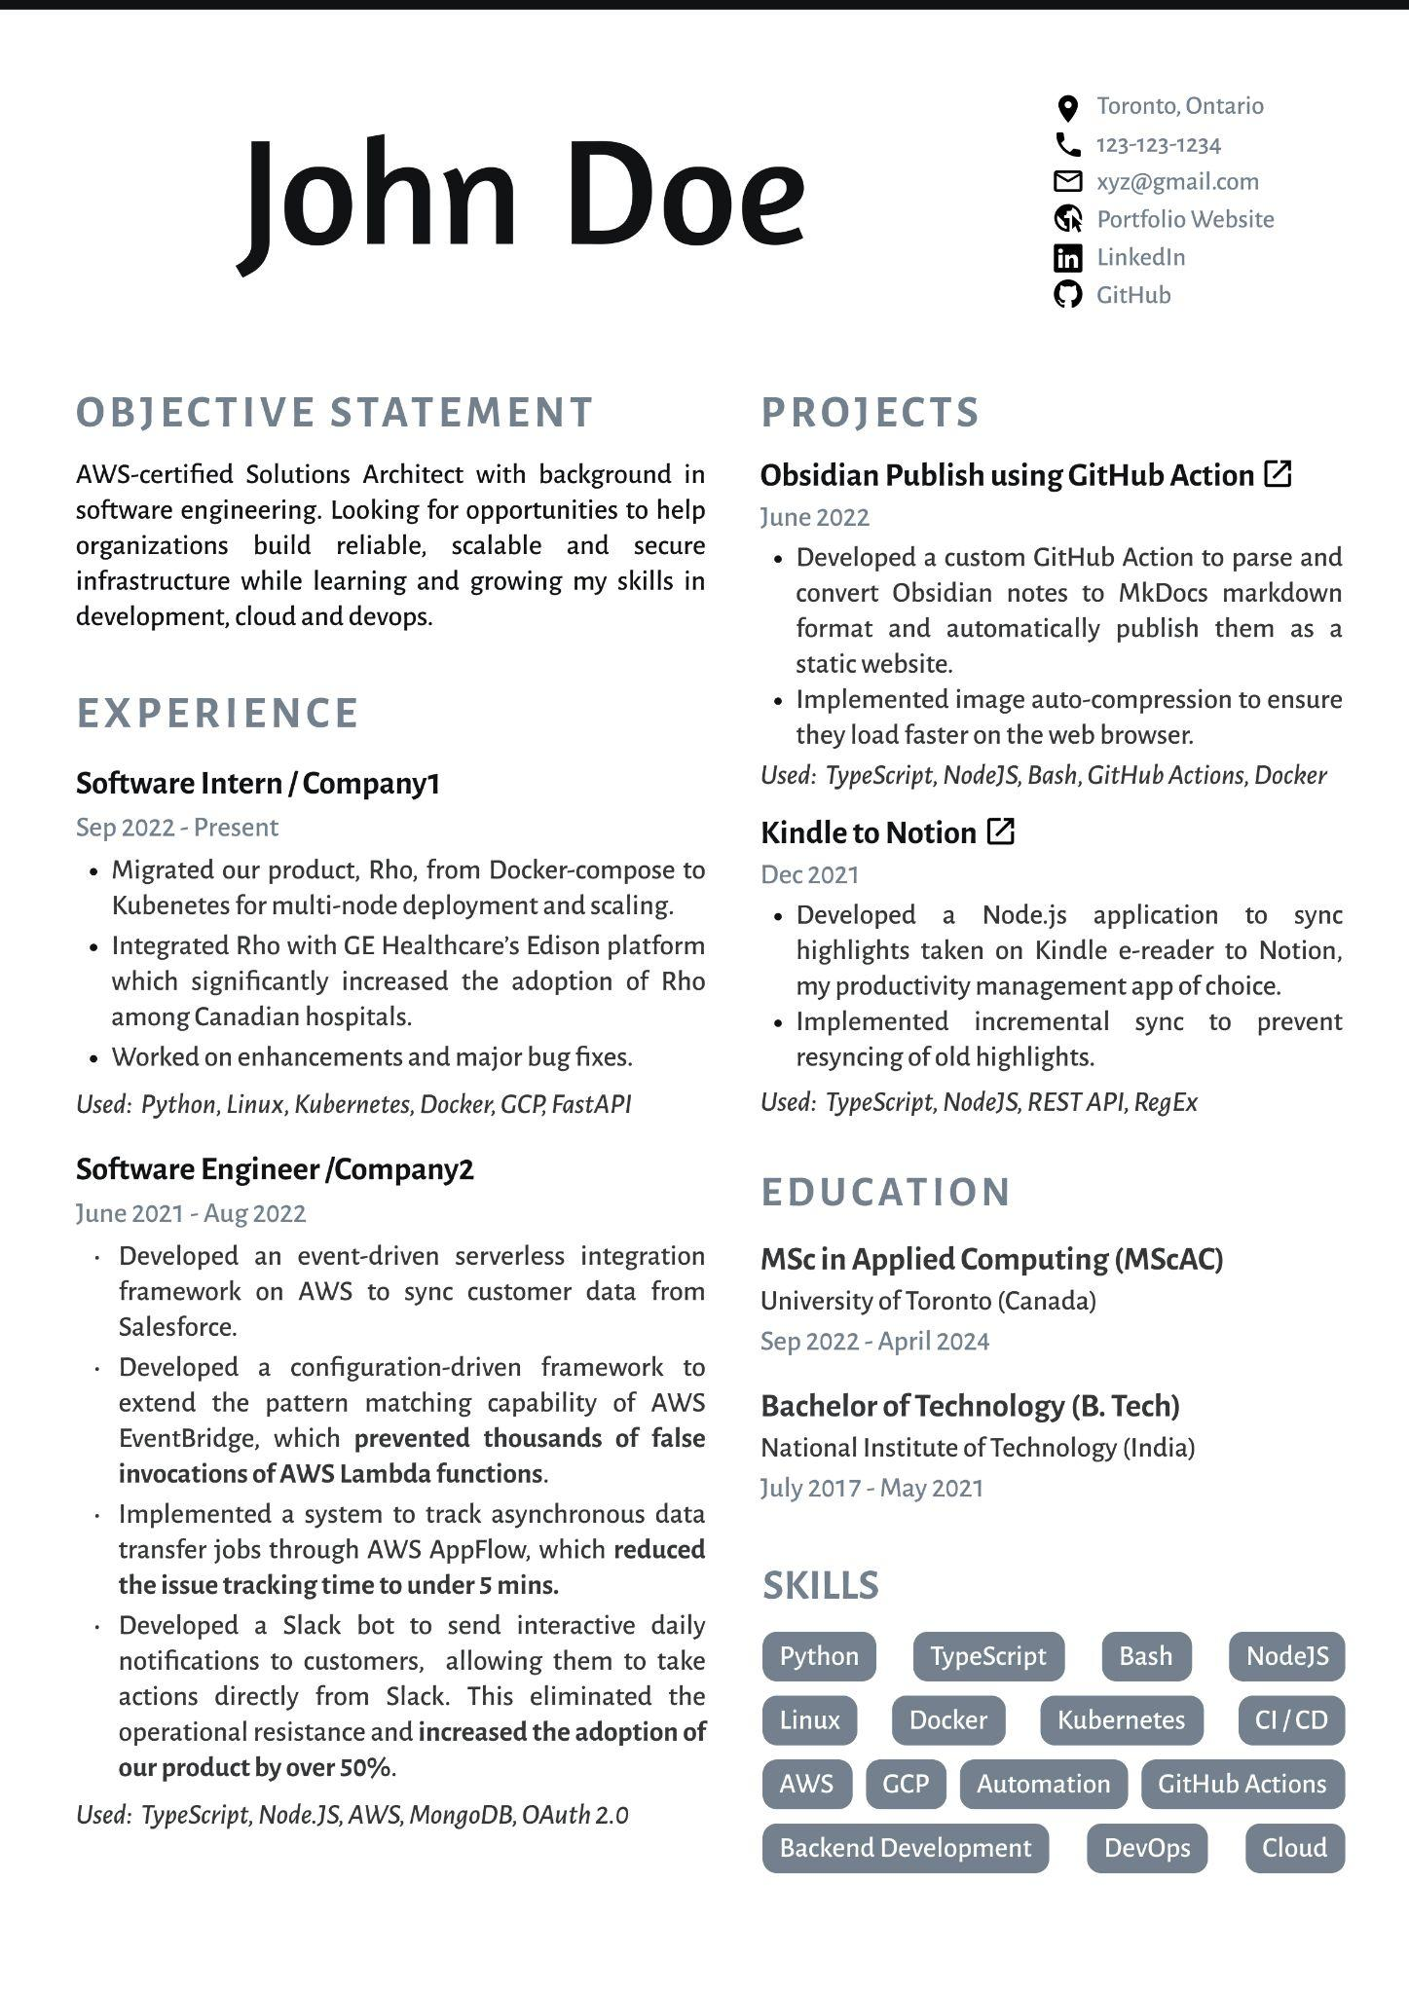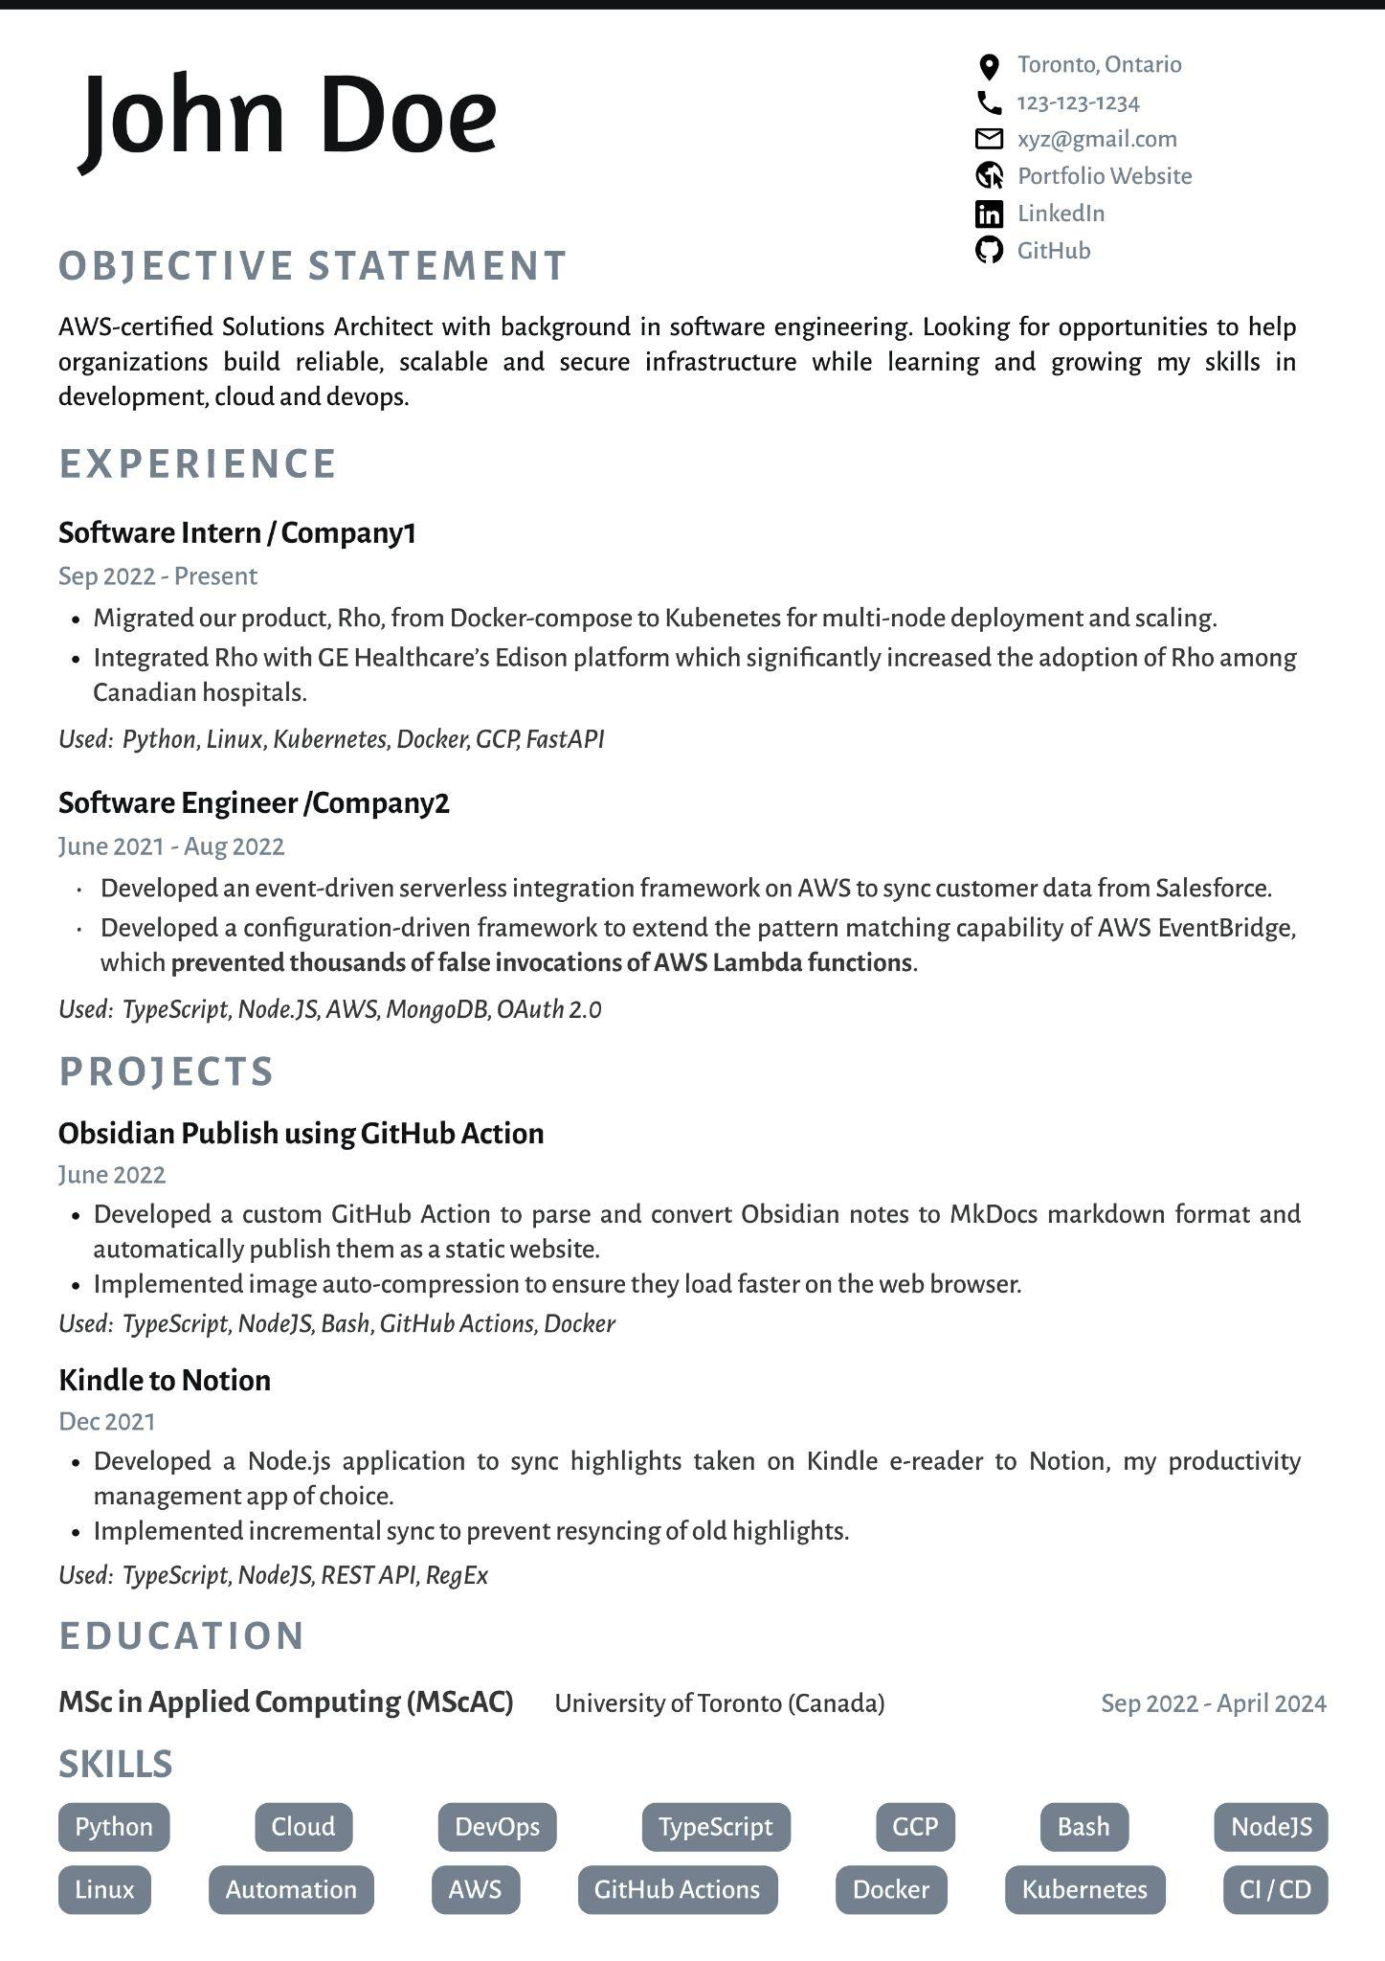

**Version 1 Version 2**

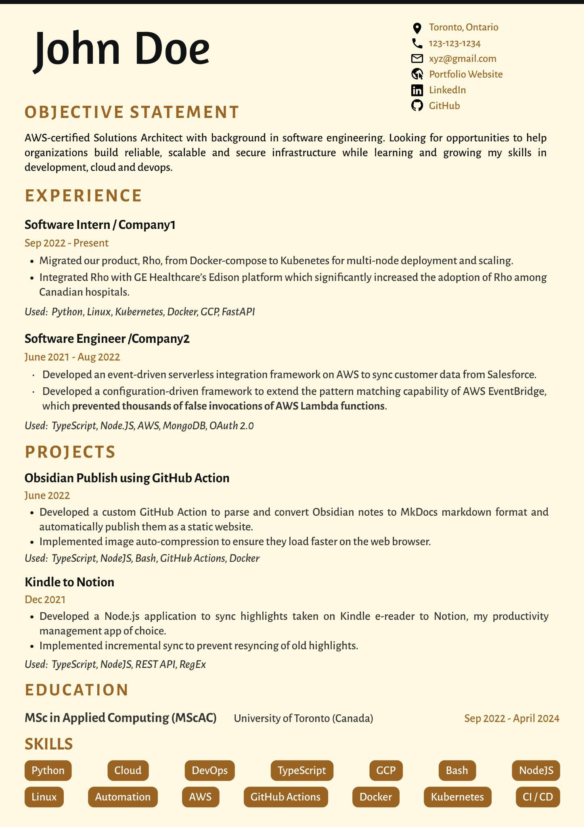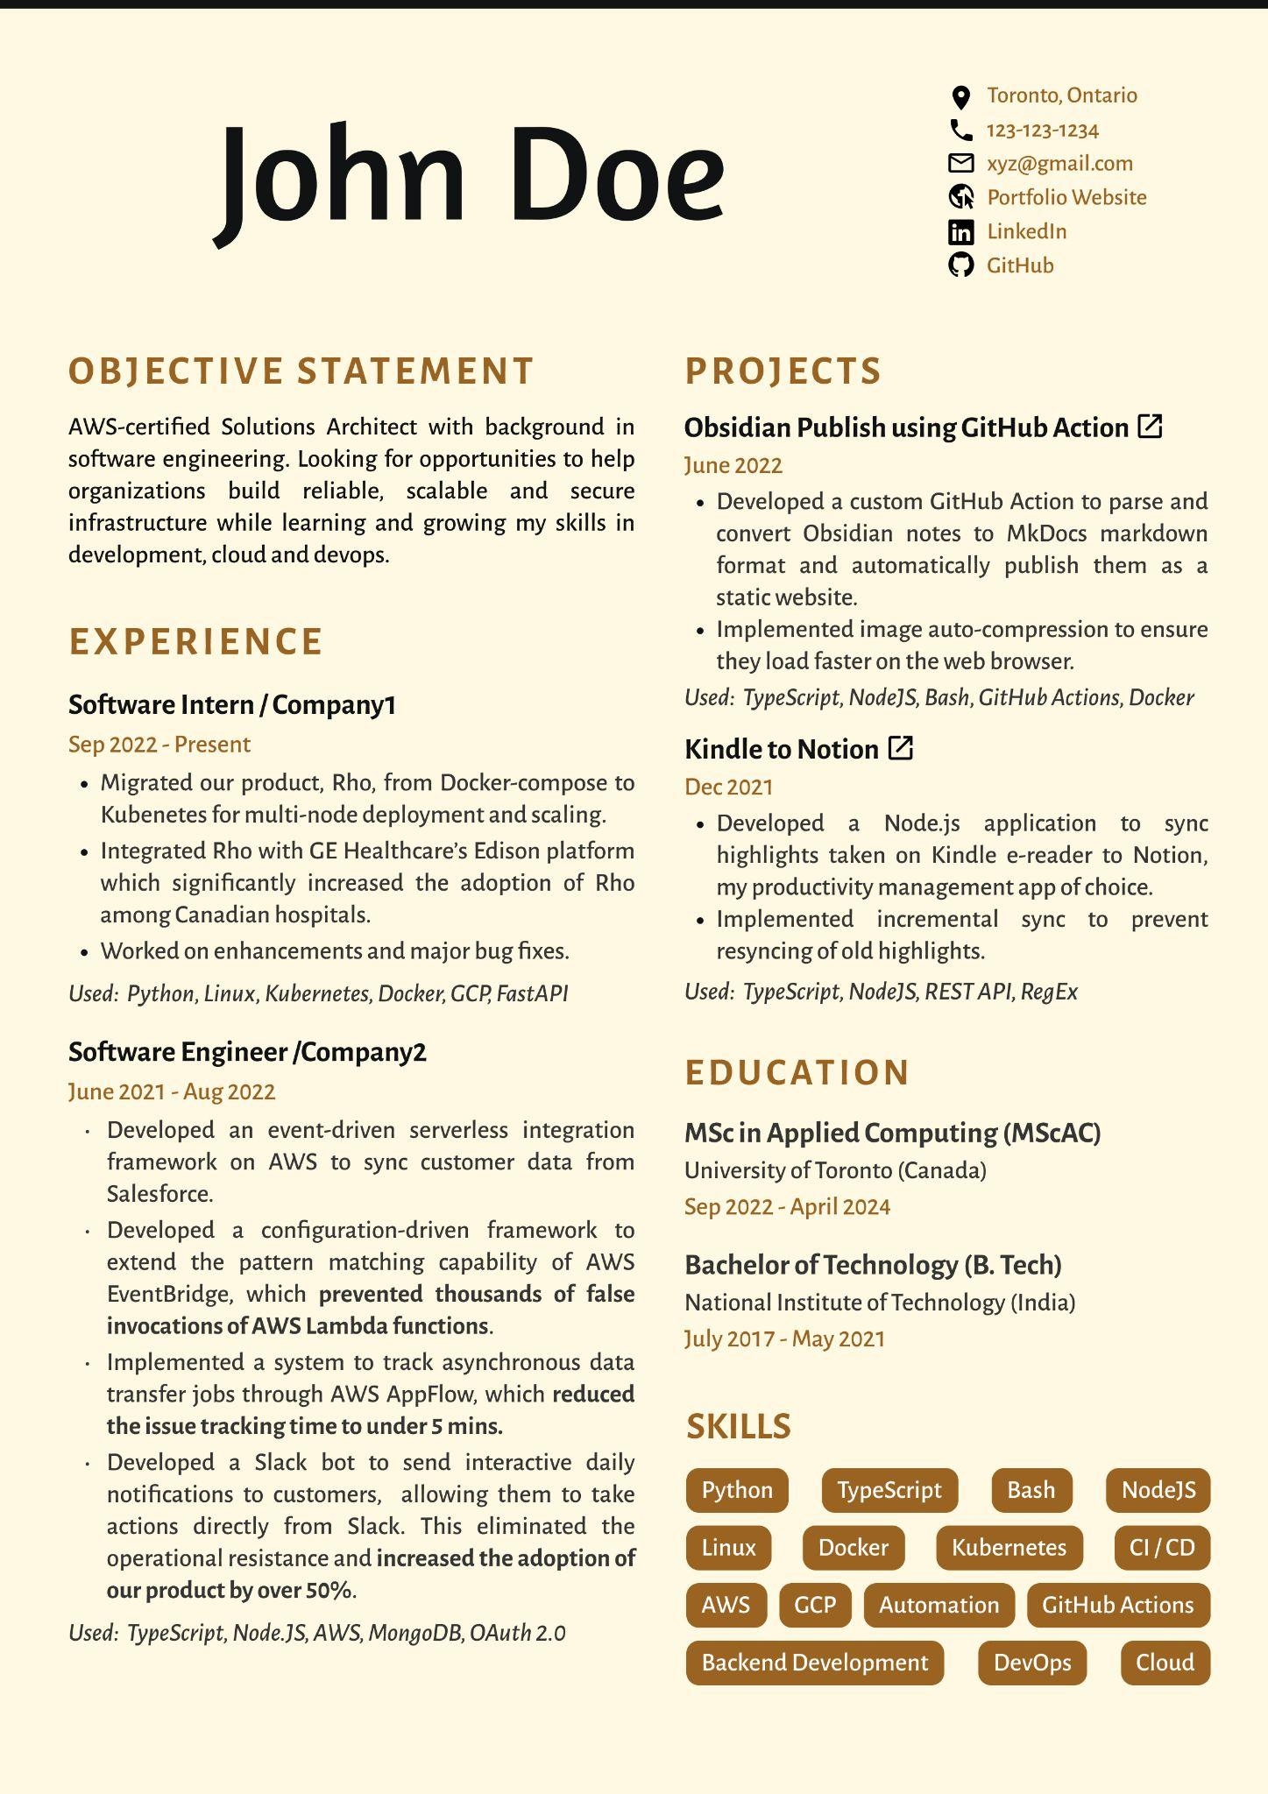

**Version 3 Version 4**

Based on user interviews we received the following feedback:

1. Reviewers have different opinions on resume structure and organizations.
2. Based on the conducted discussions, it was determined that 2 to 5 minutes was the preferred amount of time for completing the google form.
3. The users are all from the same cohort which added value to the survey as every user has the same goals. The users have different areas of expertise and different levels of industry experience which gives us different perspectives on the resumes. This added value to the survey as we were able to explore and exploit all views on resume structures.
4. To get the most out of user involvement, the best timing to distribute the form is just as important as its contents. According to user interviews, the best time to get feedback is late at night.

## **5.2 Dataset Creation**

We created web forms that contained the resume along with 4 questions that would determine how much the user found the resume appealing. The users were asked to rate each question on a scale of 1 to 5. The following questions were asked in each web form:

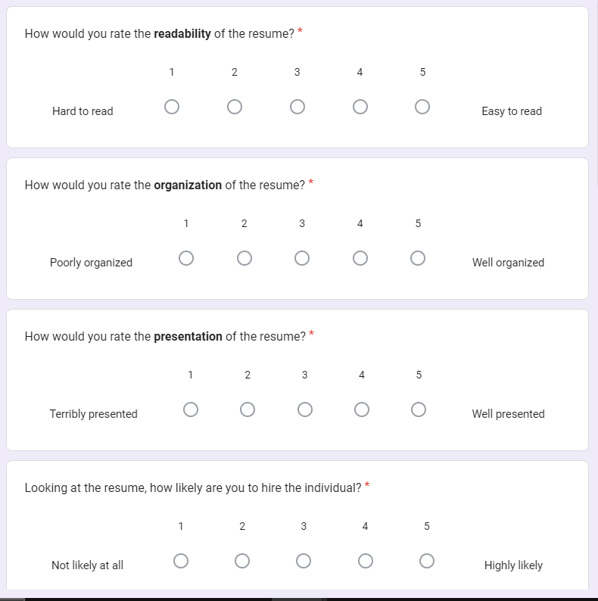

**Fig 1: Google Form Questions**

# 6. Data Visualization

We examine how a particular group responded to the resume’s design using metrics such as the response rate, and other demographic data gathered in forms.

The demographics of the users/students are visualized in the following figures. First, the distribution of students based on their academic concentration is studied. The MScAC program offers four concentrations: Computer Science(CS), Artificial Intelligence(AI), Data Science(DS), and Quantum Computing(QC). Since different concentrations have different kinds of job requirements, they may have different ideas of what the most optimal resume design should be.

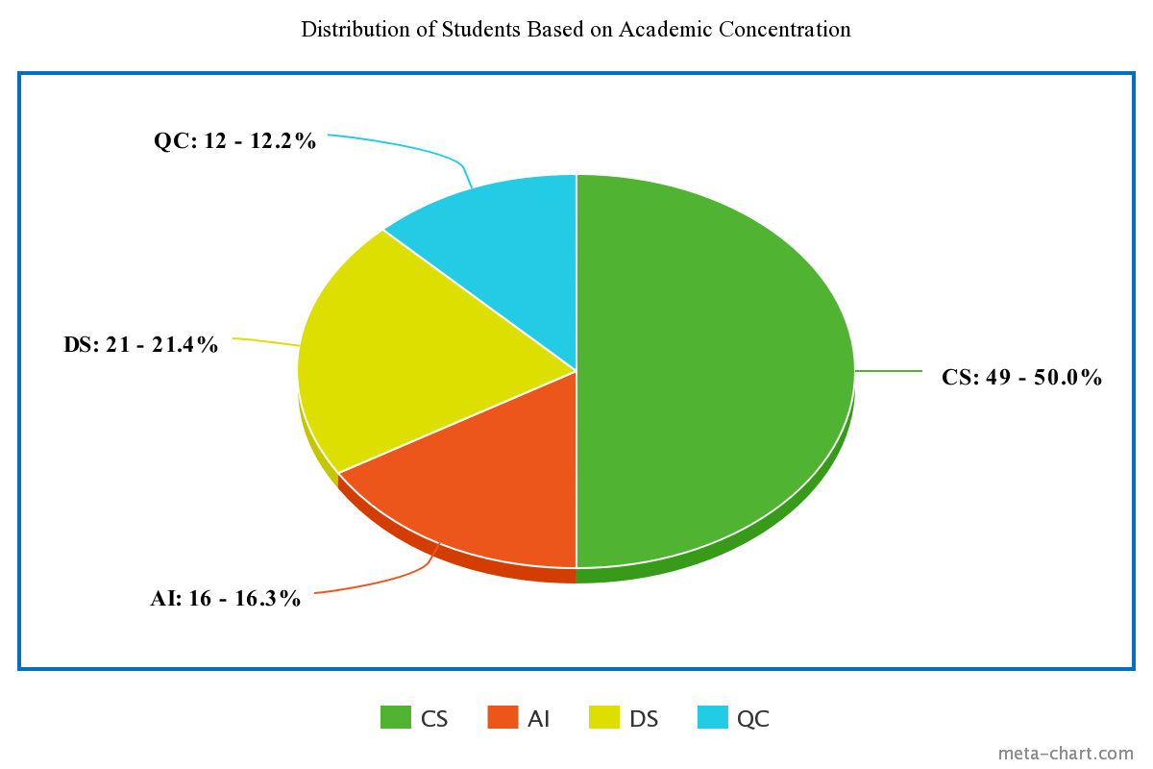

**Fig 2: Distribution of students based on academic concentration**

Secondly, we studied the total number of responses and response rates for our data collection. Out of the more than 120 people, we were able to contact, 98 users were successful in submitting their responses. Each version was sent to a group of 30 students. The distribution indicates that the resume's Version 4 has a greater response rate. Version 2's response rate was low. The table below provides a summary of the response rate's specifics:

**Table 2: The completion rate for each version of the resume**

|  | Reach | Response | Completion Rate |
| --- | --- | --- | --- |
| Version 1 | 30 | 24 | 80% |
| Version 2 | 30 | 23 | 76% |
| Version 3 | 30 | 24 | 80% |
| Version 4 | 30 | 27 | 90% |

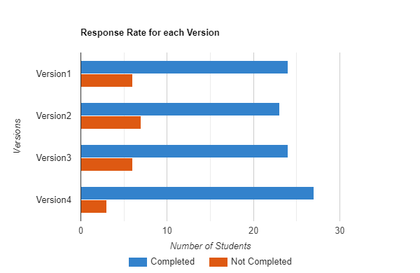

**Fig 3: The response rate for each version of the resume**

Lastly, the distribution of students based on their professional experience is demonstrated. It is observed that most of the students in the cohort have working experience of 2 to 3 years. There are only 8.2% of the cohort has no professional experience. Having working experience is relevant for our analysis as students with professional experience tend to know about the job description and requirements and then can review a resume template accordingly.

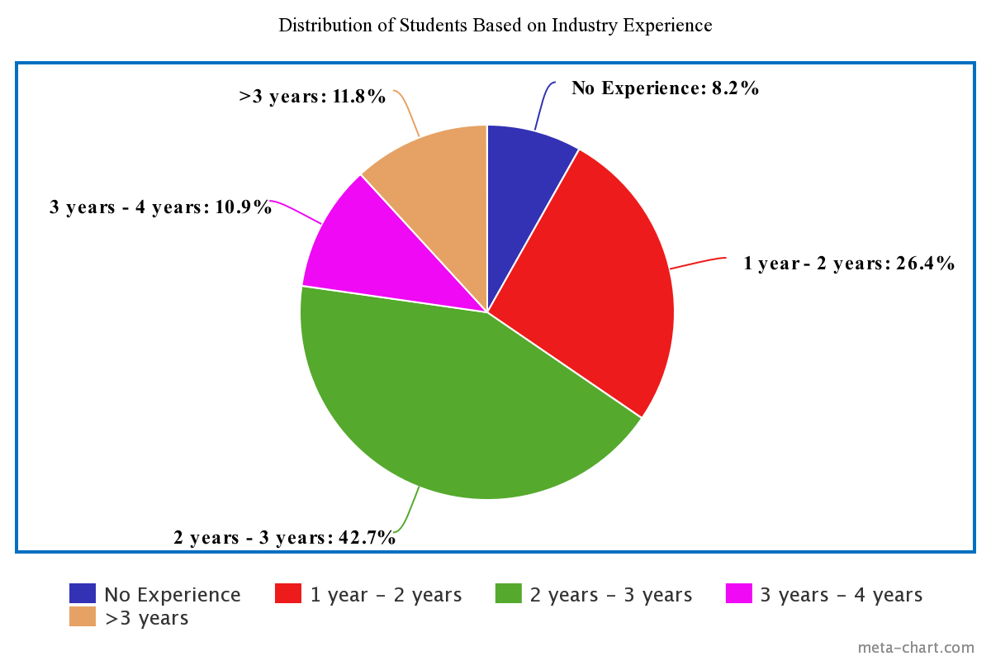

**Fig 4: The distribution of students based on their industry experience**

# 7. Adaptive ε Greedy Algorithm

The adaptive ε greedy algorithm uses the concepts of adaptive technology. This approach, which is based on the conventional "greedy," permits a controlled variation in the value of ε throughout the execution. An adaptive action that is initiated at various points during the process is used to change the value of ε. The rewards acquired from the environment are used to calculate a new value.

The exploration-exploitation tradeoff is utilized by the ε-Greedy Algorithm by

* Telling the algorithm to exploit (i.e., select the option that currently appears to be the best)
* exploring (i.e., select a random alternative with probability ε) the remaining time

In this manner, the algorithm will gradually learn which possibilities will yield it the most benefit as it continues to consider various options. To make sure that nothing is missing, though, it will occasionally select a random action. The algorithm can learn the best course of action for any given event by using this learning algorithm.

The algorithm used for the purpose of this project is from [6].

A list called resumes is created that contains the different versions.

The explore function tells the algorithm to choose randomly from the list of resumes.

The exploit function chooses the resume that has the highest cumulative reward. This is the greedy action that takes place.

The choose_resume function generates a random number between 0 and 1. If this number is greater than ε, it calls the exploit function, else the explore function is called.

**Algorithm 1: The ε-greedy algorithm to find the optimal resume structure**

| resumes = [1, 2, 3, 4]  def explore():  return random.choice(resumes)  def exploit(cumulative_rewards):  a = np.array(cumulative_rewards)  max = a.max()  unique = np.unique(a, return_counts=True)  freq_max_value = unique[1][np.argmax(unique[0])]  if freq_max_value > 1:  return explore()  else:  return resumes[np.argmax(a)]    def choose_resume(epsilon, cumulative_rewards):  if random.random() > epsilon:  return exploit(cumulative_rewards)  else:  return explore() |
| --- |

# 8. Result

Based on the visual aesthetics we hypothesized that Version 2 of the resume will be the best. From the result of the experimentation, we have enough evidence to support our hypothesis which can be observed in Fig.5. Another assumption was that Version 3 would be the worst but the experimentation result rejected this hypothesis and gave Version 4 as the worst version based on the user ratings.

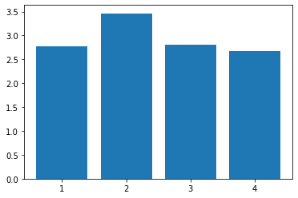

**Fig 5: Reward vs Resume Versions**

We simulated results with rewards based on the rating of the specific version of the resume out of the 4 versions. We attempt to comprehend the effects of taking into account various reward types on the outcomes displayed in Fig. The maximum mean rate value for simulations with user ratings as rewards is 0.3, while the maximum mean rate value for simulations with user ratings as regret is 0.1. Both cumulative reward and cumulative regret for the resume user rating are shown herewith.

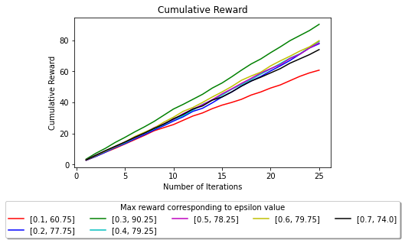

**Fig 6: The cumulative reward for different ε values where the reward is whether the user submitted the Google Form**

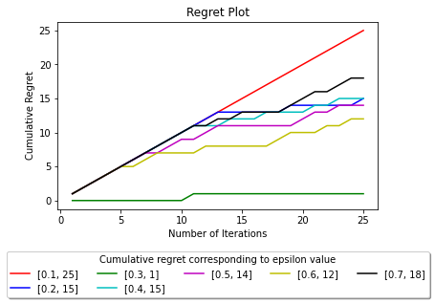

**Fig 7: The regret plot for different ε values where the reward is whether the user submitted the Google Form**

# 9. Conclusion

In this project, we presented four versions of resumes using factorial design. We collected responses from users using Google Forms and analyzed the users' demographics using different criteria like readability, presentation, organization and how likely the users think the candidate would be hired. The ε-greedy algorithm was used to find the optimal format for a resume. Our experiment results showed that Version 2 (Black and White with no columns) was the optimal resume format that was found to be the most attractive by the users based on readability and presentation. We believe this work gives an innovative methodology to a problem faced by many candidates in the hiring process. A simple and effective methodology has been used to find the optimal format.

# 10. Future Work

In this project, we used the ε-greedy algorithm to find the best resume format. As the ε-Greedy method will prefer the arm that yields good results, the project can be extended by using other algorithms like Thompson Sampling and Contextual Bandits. It is anticipated that Thompson's performs better as (1) ε-greedy with low epsilon values are far more likely to end up with a nice but suboptimal arm (2) ε-greedy with high epsilon values always sample the inferior arm more frequently. This implies that a probabilistic strategy is preferable.

We also believe that data collected from the wide pool of University of Toronto students, industry experts, and faculty could add more value. Since we have collected data for this project only from the Master of Science in Applied Computing graduate students it is very much focused on the upcoming ARIE’23 event. We can generalize this experiment further to include more streams and concentrations. Adding another generic feedback response type to the google form could also collect some valuable inputs and can cover all other aspects important for a stellar resume. These text responses can be then analyzed and a summary can be created using language models.

# 11. Resources

* [Colab Notebook](https://colab.research.google.com/drive/1Cbh11skN3PFVtKzJCnZxIoDZtCv8Ew29?usp=share_link)
* [Resumes](https://drive.google.com/drive/folders/1Tm1qRjEalggASBcdSNZ0Ac2M7tT2XS3_?usp=share_link)
* [Google Forms](https://drive.google.com/drive/folders/1SXqo9Z6bNl7-0kltZPMiPpCKCKSj2O9U?usp=share_link)

# 12. References

[1] [The ε-Greedy Algorithm for Reinforcement Learning | by Avery Parkinson | Analytics Vidhya | Medium](https://medium.com/analytics-vidhya/the-epsilon-greedy-algorithm-for-reinforcement-learning-5fe6f96dc870)

[2] [ε-Greedy Q-learning | Baeldung on Computer Science](https://www.baeldung.com/cs/epsilon-greedy-q-learning)

[3] Guo, D., Ktena, S.I., Huszár, F., Myana, P.K., Shi, W., & Tejani, A. (2020). Deep Bayesian Bandits: Exploring in Online Personalized Recommendations. *Fourteenth ACM Conference on Recommender Systems*.

[4] Shi, L. and Li, B., 2016. Design of Experiments and Web Page Designs: Theories and Applications. In Proceedings of the Internafional Conference on Industrial Engineering and Operafions Management (pp. 956-962).

[5] dos Santos Mignon, A. and da Rocha, R.L.D.A., 2017. An adaptive implementation of ε-greedy in reinforcement learning. Procedia Computer Science, 109, pp.1146-1151.

[6] [The ε Greedy Algorithm For Reinforcement Learning | by Avery Parkinson | Medium](https://medium.com/analytics-vidhya/the-epsilon-greedy-algorithm-for-reinforcement-learning-5fe6f96dc870)

[7] [Multi-Armed Bandit Analysis of ε Greedy Algorithm | by Kenneth Foo | Analytics Vidhya | Medium](https://medium.com/analytics-vidhya/multi-armed-bandit-analysis-of-epsilon-greedy-algorithm-8057d7087423)

[8] Kohavi, R. and Longbotham, R., 2017. Online Controlled Experiments and A/B Testing. Encyclopedia of machine learning and data mining, 7(8), pp.922-929.